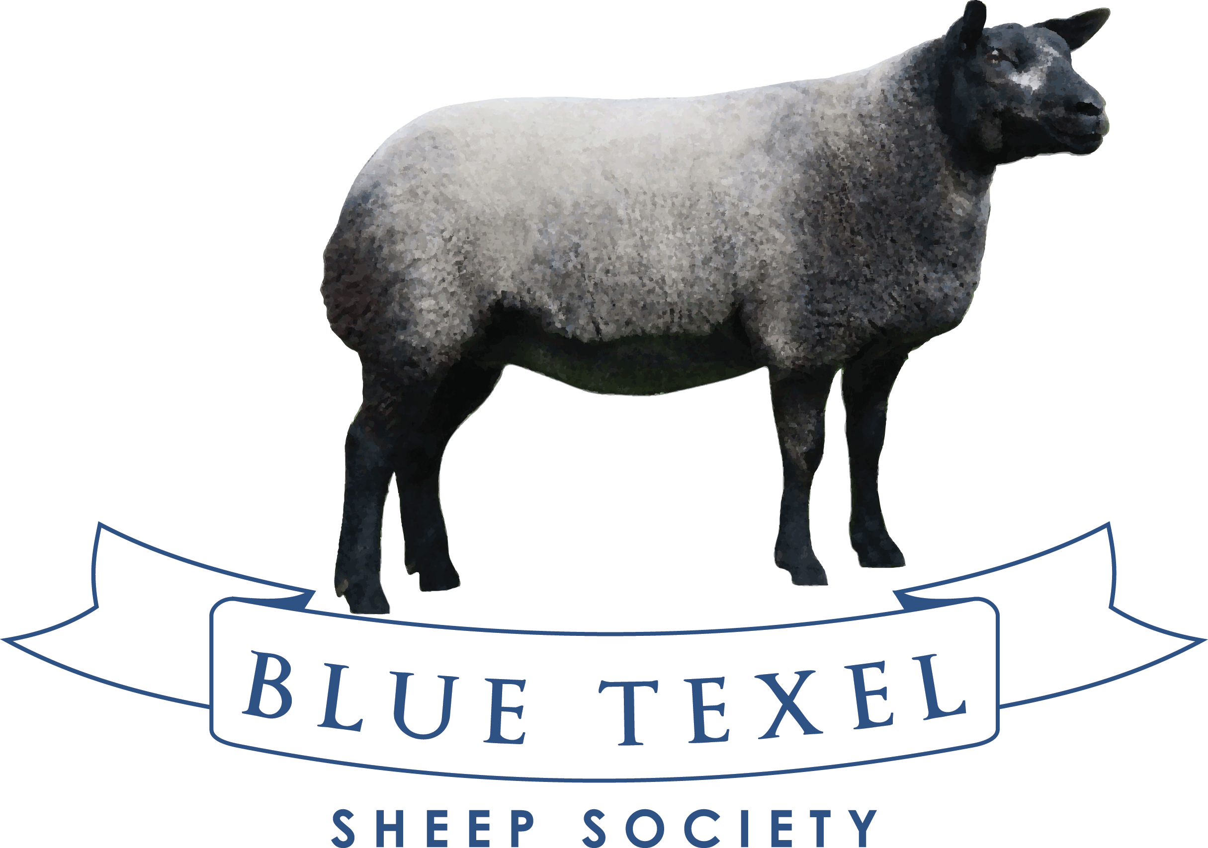

MILLEND DISPERSAL SETS NEW BREED RECORD

The highly anticipated final instalment of the Millend Dispersal Sale from Russell & Gill Watkins did not disappoint. The 18 lots forward for the Sale were turned out to perfection and a real credit to the Watkins family who will be sadly missed from the Breed. The packed ringside ensured that trade was enthusiastic from start to finish.
Setting a new Breed Society Record with the sale of their stock Ram ‘Hackney All-Gold’ saw Millend break their previous record of Top Priced Aged Ram with Hackney X-Rated smashed. Intent bidding ensured that Hackney All-Gold was eventually knocked down for 6000gns to Andy & Janet Carson for their Little Whisker Flock in Northern Ireland.
Bidding was off to a flying start when the first Shearling Ewe that entered the ring Lot 230 MILLEND BELLE scanned in lamb with twins to the Record Breaker Hackney All Gold sold for 3400gns to Andy & Janet Carson, a big powerful ewe sired by NANTYDERRI NAN/16/00090 topped the female trade of the day.
Following this Lot 231 another fantastic shearling MILLEND BAA-BRA scanned twins to Hackney All-Gold again sired by Nantyderri NAN/16/00090 out of MILLEND EXHIBIT sold to Young Breeder Iestyn Thomas for his SAWDDE Flock.
Other noted prices include 1650gns for Lot 233 MILLEND BLUE BELL sired by Cairnrock Am Yer Man out of a Hackney X-rated dam, scanned twins to Hackney All Gold sells to Park & Baird, Malmesbury. 1600gns for Lot 234 MILLEND BLUE EXAMPLE again going home with Iestyn Thomas.
Russell & Gill Watkins have achieved great success with their Blue Texel Flock over the years at Society Shows & Sales, we wish the family every success and hopefully one day they might return to the breed. We hope all purchasers enjoy their new additions and look forward to seeing some progeny in the future.
MILLEND SALE AVERAGES
1 AGED EWE - £577.50
16 SHEARLING EWES - £1464.75
1 AGED RAM - £6300

Auctioneers: McCartneys
Worcester Livestock Market, The Heath Meadows, Nunnery Way, Worcester WR4 0SQ
Tel: 01905 769770 Email: worcester@mccartneys.co.uk www.mccartneys.co.uk

